Stakeholder Management Strategy
  - furlink

Asia Pacific College
Humabon Place, Magallanes Village
Makati City, Metro Manila, 1232

March 2026

Table of Contents
Introduction 1
Identify Stakeholders 1
Key Stakeholders 2
Stakeholder Analysis 3
Sponsor Acceptance 7

Introduction
The Stakeholder Management Strategy for furlink will be used to identify and classify project stakeholders; determine stakeholder power, interest, and influence; and analyze the management approach and communication methodology for project stakeholders. This will allow us to identify key influential stakeholders to solicit input for project planning and gain support as the project progresses. This will benefit the project by minimizing the likelihood of encountering competing objectives and maximizing the resources required to complete the project.
Early identification and communication with stakeholders are imperative to ensure the success of furlink by gaining support and input for the project. Some stakeholders may have interests which may be positively or negatively affected by the project. By initiating early and frequent communication and stakeholder management, we can more effectively manage and balance this interest while accomplishing all project tasks.

Identify Stakeholders
The team will conduct a multi-layer discovery methodology to identify all parties influenced by or capable of influencing furlink. This process was designed to mitigate the risk of hidden stakeholders, which could otherwise result in scope creep or deployment delays. The identification process followed three primary phases:
- Market Research: The team will conduct an environment scan of the pet care grooming industry to identify the primary economic actors, including service providers or the grooming salons and the consumer base or the pet owners, as well as indirect influencers such as market competitors.
- Brainstorming: Internal session will be held to map out the organizational and academic landscape. This helps identifying internal stakeholders—such as the Project Manager, Lead Developer, Quality Assurance, and Team Lead—as well as institutional stakeholders like the Project Advisers from Asia Pacific College.
- Interview: To move beyond theoretical identification, the team will conduct targeted interviews. This step will serve as a verification mechanism to confirm that the identified users’ needs aligned with the project’s objectives and uncover secondary stakeholders, such as marketing personnel, who are essential for the platform’s long-term viability.
Stakeholder Inclusion Criteria
The team will use the following criteria to determine if an individual or organization should be included as a stakeholder:
- Is the person or their organization directly or indirectly affected by the furlink platform?
- Does the person or their organization hold a position from which they can influence project decisions?
- Does the person have an impact on project resources such as technical tools, personnel, or academic funding?
- Does the person possess specialized skills or technical capabilities required by the project?
- Does the person potentially benefit from the project or are they able to resist the transition to a digital booking system?
By combining top-down research with bottom-up validation, the team will establish a robust register that ensures a holistic approach to project management.

Key Stakeholders
As a follow-on to the identification process, the team will identify a sub-set of stakeholders categorized as Key Stakeholders. These individuals or groups are determined by their significant influence over project outcomes, the extent to which they are affected by the platform, or their potential resistance to the transition from manual to digital booking system.
Because these key stakeholders require the most intensive communication and active management, the Project Manager will be responsible for establishing a customized engagement plan. This plan will aim to obtain feedback on:
- Their desired level of participation and involvement in project milestones.
- The preferred frequency and method of communication.
- Any specific concerns, technical requirements, or conflicting interests that may arise during the Software Development Life Cycle.
Based on this gathered feedback, the Project Manager and Team Lead may decide to involve these stakeholders in specific focus groups, beta testing reviews, or academic gate reviews to ensure the project remains aligned with both user needs and academic standards. Maintaining thorough communication with this group is essential to ensure that necessary resources remain available and that all project risks are addressed early.

Stakeholder Analysis
Once all the furlink’s stakeholders have been identified, the team will categorize and analyze each stakeholder. The purpose of this analysis is to determine the stakeholders’ level of influence, plan the management approach for each stakeholder, and to determine the appropriate levels of communication and participation each stakeholder will have on the project.
The team will first categorize stakeholders by their specific organization. Following this categorization, the team will utilize two primary tools to quantify and visualize stakeholder impact:
- Power/Interest Matrix: It will be used to illustrate the potential impact of each stakeholder by plotting them based on their level of authority or power and their level of concern for project outcomes or interest.
- Stakeholder Analysis Matrix: It is a table that will be used to capture specific stakeholder concerns, their required level of involvement, and the designated management strategy based on their placement in the power/interest quadrants.

Power/Interest Matrix
Key | Organization | Name | Power (1-5) | Interest (1-5)
A | Management Team | Lalainne Andaya | 5 | 5
B | Management Team | Feliz Angelica Salting | 5 | 5
C | Development Team | Atasha Frances Gayle Doria | 4 | 5
D | Testing Team | Michelle Reina Pineda | 4 | 5
E | Asia Pacific College Faculty | Mr. Gonzalo Gumogda | 4 | 4
F | Asia Pacific College Faculty | Mr. Gil Ballesca | 3 | 4
G | Users | Service Providers | 3 | 3
H | Users | Pet Owners | 3 | 3
I | External | Competitors | 1 | 2

Stakeholder Analysis Matrix
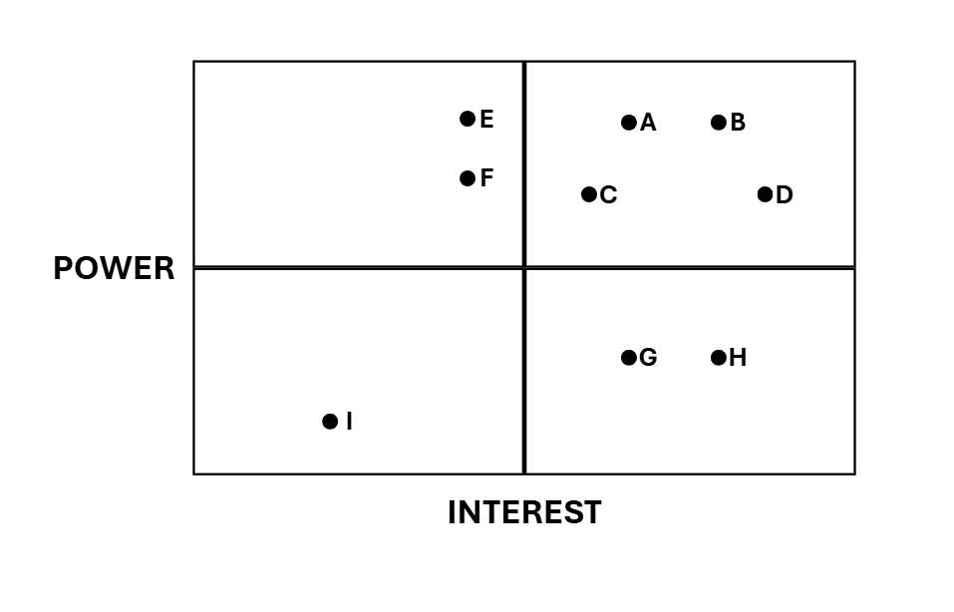
Based on the power and interest analysis and chart above, stakeholders E and F, in the upper left quadrant, must be kept satisfied by providing a high-quality documentation and regular milestone updates to ensure all academic requirements are met. On the top right quadrant are stakeholders A, B, C, and D or the key players who are involved in all levels of project planning, technical development, and marketing. With that, the overlapping roles requires the team to hold daily stand-up meetings to ensure alignments. Stakeholder I on the lower left quadrant needs to be monitored regularly for market trends, requiring minimal direct management effort. Lastly, stakeholder G and H on the lower right quadrant must be kept informed through progress updates and beta-testing opportunities to ensure the final product meets market needs.
The stakeholder analysis matrix will be used to capture stakeholder concerns, level of involvement, and management strategy based on the stakeholder analysis and power/interest matrix above. The stakeholder analysis matrix will be reviewed and updated throughout the project’s duration to capture any new concerns or stakeholder management strategy efforts.

Stakeholder | Concerns | Quadrant | Strategy
A | Balancing project management duties with active development and marketing research. | Key Player | Involved in all levels of project planning and change management; frequent internal sync-ups are mandatory.
B | Managing technical debt, meeting tight deployment deadlines, and achieving social media traction. | Key Player | Participatory member in all status meetings and gate reviews; lead responsibility for release documentation.
C | Technical architecture scalability and the effectiveness of marketing assets for user acquisition. | Key Player | Frequent communication with the Project Manager and Team Lead to align technical implementation with project milestones.
D | Ensuring zero critical bugs at launch and verifying if the app meets validated market needs. | Key Player | Solicit frequent updates on feature completion to begin regression testing early; provide reports on market research.
E | Proper adherence to the SDLC and meeting all Asia Pacific College academic requirements. | Keep Satisfied | Communicate project specifications and academic deliverables as required to ensure institutional satisfaction.
F | Accuracy of technical diagrams and ensuring the system development matches proposed designs. | Keep Satisfied | Allow technical leads to work closely with the adviser to validate documentation and address expertise-specific questions.
G | Transitioning from manual to digital processes and the accuracy of generated business reports. | Keep Informed | Provide frequent status reports and obtain feedback on B2B requirements or changes to the salon interface.
H | Data security of pet information and the ease of the booking/payment user experience. | Keep Informed | Communicate test results and performance specifications; solicit feedback during beta-testing phases.
I | Loss of market share to furlink’s automated and niche-focused features. | Minimal Effort | Monitor market trends and update competitor research periodically; minimal direct communication required.

Sponsor Acceptance
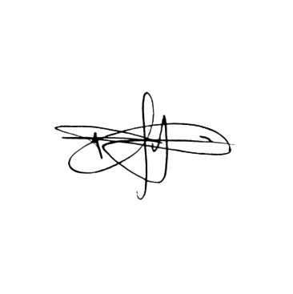
Approved by the Project Sponsor:

______________________________________ Date: April 7, 2026
Manuel R. Doria Jr.
Project Sponsor Representative

